JOHN LIN
C R E D I T A N D C O L L E C T I O N S
551-404-0739

Johnlinnj@gmail.com 495 Brickell Ave
Miami FL 33131

W O R K E X P E R I E N C E



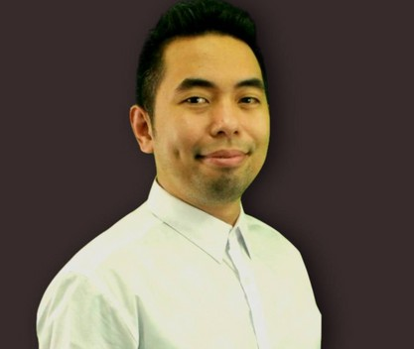

E D U C A T I O N

Rutgers University
Bachelor of Arts in Business Admin

Bachelor in Business Admin Member of the Design Club Cumulative GPA: 3.72

A C C O M P L I S H M E N T S

Reduced DSO from 100+ days to 62 days within a 4 month timeframe.
2012, 2013 & 2014 Top Collector Award from Discover Bank.
Proven track record of improving cash position by managing credit & collections at the highest level.
High School Perfect Attendance Award

Axiom Software Laboratories, NYC
Sr. Billing & Collections Analyst
November 2019 - September 2023
Supervise collections and billing function of the company's 55 jurisdictions within North America, EMEA, LATAM and APAC, working directly with key stakeholders at global financial institutions, regional CFOs and business tech executives responsible for software purchases.
Maintain DSO of less than 64 days by strategically applying pressure to ensure clients' accounts are within agreed-upon payment terms.
Strategize with Collections Director & Global Controller to position the company for best possible outcome while mitigating credit risk in complex situations.
Direct the team to stay ahead of clients by anticipating billing issues, expediting PO approvals, understanding tax implications & annual CPI adjustments

Intersection Media LLC, Secaucus, New Jersey
Sr. Credit & Collections Analyst
March 2018 - October 2019
Assist Director of Collections in effectively analyzing accounts by looking at key indicators: average days to pay within the last year in relation to year- to-date sales; identify whether payment trend has improved or deteriorated within that same period and engage with business owners to determine the changes in their business during that period which would have impacted the trend.
Analyze credit risk by performing credit reviews of new and existing customers in order to make well-informed decisions on credit worthiness
Quickly identify key metrics and interpret them to gain insight on the customer’s cash flow and overall health of business.

Abco, Long Island City, NYC
Credit Manager
November 2016 - March 2018
Maintain a credit portfolio of over 500 assigned customer accounts, ensuring that past due and collection metrics are achieved.
Perform credit reviews of new and existing customers, considering information such as financial information of the customers, trade and bank references, publications and information provided by sales, in order to determine their credit worthiness.
Develop an understanding of customers’ businesses in order to effectively assess credit risk & determine root cause of past dues

Intersection Media LLC, Secaucus, New Jersey
Credit and Collections Analyst
May 2015 - November 2016
Conduct effective and professional collection calls and email on high volume accounts.
Complete credit investigation on existing/new accounts per assigned value threshold.
Develop constructive working relationships with Account Executives regarding discrepancies, billing adjustments, etc.

